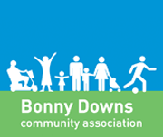
Bonny Downs Community Association
Volunteer Handbook

Welcome | 1
The journey of BDCA so far | 2
Our venues | 3
Vision, Mission, Values | 4
Meet the Team | 4
Important Information | 5
Checklist and Notes | 7
Contents:

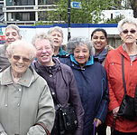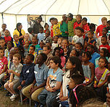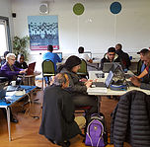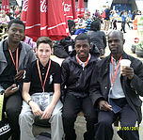

Welcome to Bonny Downs Community Association​

Firstly, welcome to Bonny Downs Community Association, and thank you for giving your time to help us serve our local community. All our volunteers are amazing people who give their time to serve others. You are really appreciated. This handbook is designed to give you a clear picture of all the work that BDCA does, as well as to set out some general guidelines about volunteering with us.

Whether you want to contribute to the life of your community, or to further your skills and experiences, to meet new people or have a particular skill or passion to share, we are pleased that you have chosen BDCA. We hope that by the time you have read this handbook you will have a better understanding of what we do and why we do it. We hope you will feel part of the Bonny Downs Story and discover your place in it.

The Journey of BDCA (so far!)...
In 1998, the members of Bonny Downs Baptist Church decided to launch a community development charity so they could better support their neighbours in need. The first project of the charity was to renovate a nearby derelict community centre, which had stood empty for several years.
The vision was to create a building that would benefit local people from all walks of life and become a hub for local community projects. Our first team of volunteers from Bonny Downs Church began fundraising, liaising with the council, recruiting other local residents and getting their hands dirty demolishing the old building. After many years of hard work, we reopened the centre, now called The Well, in 2001.
In 2002, BDCA took over responsibility for a disused and neglected 9 acre space in the heart of our community called Flanders Playing Field. BDCA worked in partnership with Newham Council to transform this overgrown jungle into a high quality sports venue complete with a purpose-built indoor facility which we named The Bobby Moore Sports Pavilion, which opened in 2009.
BDCA secured further funding from the Big Lottery Local Food Fund to bring to life the north-west corner of Flanders Playing Field through the creation of a new eco-friendly community food growing garden in 2013.
We are proud of what our community has achieved together.
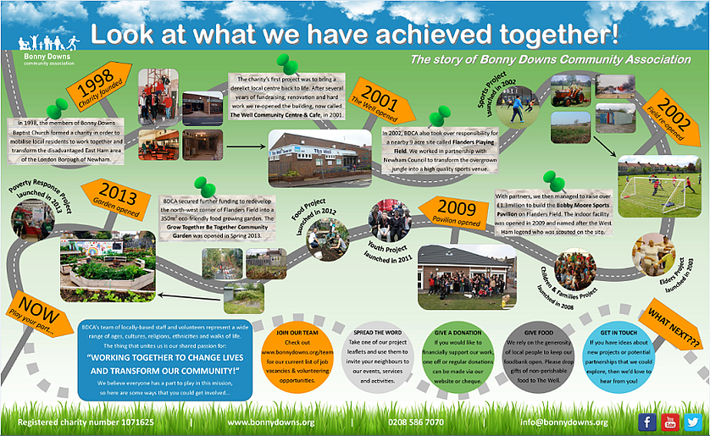

Our venues….
BDCA manages the following local venues:
- Flanders Playing Field (Entrance on Napier Road), East Ham, London E6 2SG
- Bobby Moore Sports Pavilion,118 Napier Road, East Ham, London, E6 2SG
- Grow Together Be Together Garden, North-west corner of Flanders Playing Field (Entrance on Wellington Road), East Ham, London E6 6EB
- The Well Community Centre, 49 Vicarage Lane, East Ham, E6 6DQ
The foodbank and community choir are in Bonny Downs Church Hall, 18 Darwell Close, East Ham, London E6 6BT. And the Kitchen Garden is located on Flanders Road opposite the old church building.
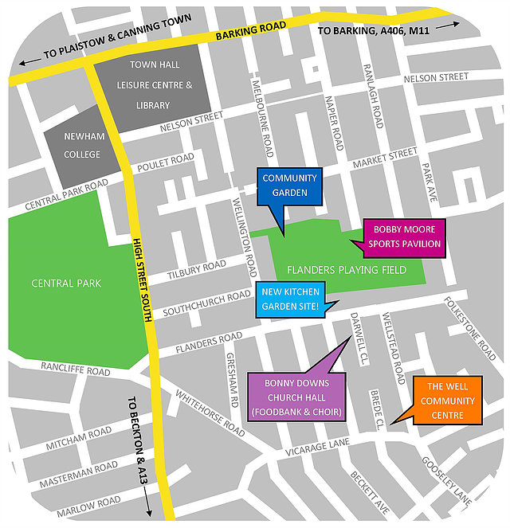

Our Vision, Mission and Values….
Our motto
“Working together to change lives and transform our community”

Our Vision
“A thriving community where everyone feels connected, valued and fulfilled”

Our Mission
“Working to break down barriers, bring people together and build people up”

Our values

INCLUDING: Everyone is a valuable member of our community and we are shaped to care for and support each other, celebrating diversity, challenging prejudice, breaking down barriers, building bridges and widening horizons.

CELEBRATING: We affirm the goodness and beauty we see in individuals and creation. We encourage an attitude of thankfulness and celebration – even in the midst of life’s disappointments and challenges. We view the glass as half full, not half empty and the world as a place of possibility. Every cloud has a silver lining and we seek to make and recall good memories together.

EMPOWERING: Our role is to work WITH others, encouraging everyone to be the best they can be in body, mind and spirit, developing their own unique gifts and seizing opportunities. We don’t do things for people that they can do for themselves or impose our views or agendas on others. We support people to overcome barriers which prevent them from fulfilling their immense potential towards greater resilience both individually and collectively.

Meet the Team…

We have put together a document with photos and work contact details of all our staff members, please do ask us if you would like a copy. Some staff members you may want to contact include:
- Peter Laing (Chief Executive of the organisation): peter.laing@bonnydowns.org
- Tracey Pease (Finance Manager): tracey.pease@bonnydowns.org
- Jessica Craig (Fundraising and Marketing Coordinator): jessica.craig@bonnydowns.org
- Angie Allgood (Safeguarding Officer): angie.allgood@bonnydowns.org
- Chelle Coulton (Strategy Working Group team member specialising in Upshot and PQASSO related issues across the charity) chelle.coulton@bonnydowns.org
- Deepa Selvaraj (Finance and Administration Assistant) deepa.selvaraj@bonnydowns.org

Project Coordinators/Managers for each of our departments can also be contacted at:
- Elders: Elders@bonnydowns.org
- Children & Families: families@bonnydowns.org
- Sports: sports@bonnydowns.org
- Youth: youth@bonnydowns.org
- Food: food@bonnydowns.org
- Poverty response: support@bonnydowns.org
- Growing Strong (for children in need): growingstrong@bonnydowns.org
- After School Club: afterschoolclub@bonnydowns.org

Important Information for our volunteers…

You are a valued member of our team. As such, there is important information for us to share with you, and important information for you to give to us.

Personal and Contact Details- Please make sure you have completed a Registration form and that we have up-to-date information for you. Please ensure we have emergency contact details, and that we are aware of any medical conditions. We keep your details in our secure database, and we may use this information for monitoring and evaluating purposes. If you do not wish us to use your photographs, or other personal information, please let us know.

Time Commitment- You should have a Volunteer Agreement. A copy of such an Agreement is at the end of this handbook. Please note the details of the days and times you have agreed for your role. Note who your line manager is, along with their contact number. If you are unable to attend on any of times agreed, please let your line manager know as soon as possible, so that suitable cover can be arranged.

Personal Property- We are unable to accept responsibility for any personal belongings brought onto our premises. We strongly recommend that you do not bring any items of value with you whilst undertaking your role. Please ask your line manager for arrangements were personal items can be stored, whilst you undertake your volunteering duties.

Media, Social Media and Photos- Please do not use personal phones or cameras to take photographs of our activities or other users whilst volunteering. Please be mindful of others if using social media and do not post anything without permission. Please make sure you read our Media & External Communications policy, which is available on request.

Problems- At BDCA, everyone should be treated with dignity and respect. We hope that you enjoy all aspects of volunteering at BDCA. However, if any problems arise, please speak to your line manager, and they will attempt to resolve the difficulties with you. We also have a complaints procedure that is available on request. We also ask that you treat everyone fairly and with respect. Please make sure you have read our ‘Equality Diversity and Inclusion Policy’ and our ‘Dignity at Work Policy’. If there is anything you do not understand, please speak to your line manager.

Safeguarding- if your role requires that you work with children and/or vulnerable adults, we are required to undertake a DBS check on you. We will explain the procedure to you, and we will cover the costs. It is important that you read and understand our ‘Safeguarding Policy’. This will be made available to you. If you have any questions, or if there is anything about our policy that you do not understand, please speak to your line manager.
Policies- In order to function effectively BDCA have a number of policies and procedures. These are about the ways we do things, how we do things and why we do things. Certain behaviours are expected of everyone who works with us. All our policies are available on request, but your line manager will decide the ones that are important for you to understand. We have policies on: Safeguarding, Confidentiality, Health & Safety, Data Protection, Use of BDCA equipment, Media and external communications policy, Dealing with anger and aggression, Drugs, alcohol, smoking and vaping.

Expenses- BDCA are able to reimburse volunteers on their travel costs, if they use a bus or train to attend their duties. This is on the production of a receipt and the payment request forms are available in the front office. A number of our projects have free meals, which you are invited to, or a voucher for lunch in our Community Café is available, if you are volunteering for over 4 hours over the lunch period. Please ask your line manager if you are eligible for this.

Reference Requests- We hope that you enjoy all aspects of volunteering with us. We understand that for some volunteers you are hoping to move into paid work, or into other new ventures. If you require a reference, please speak to your line manager- who will be able to discuss the role you are moving onto, and will provide you with relevant references and support as you move on.

Volunteer and Staff Meetings – BDCA loves gathering people together, and you are an important part of our team. Your line manager will be able to tell you of our regular staff and volunteer meetings, and our annual celebrations. We also have ‘WELCOME TO BDCA’ event, and we invite all who are interested to find out more about our organisation and the work we do. Please ask you line manager for details of the next Welcome event.
Our website and Social media sites- Please keep in touch with us through social media. You can follow us on https://www.facebook.com/bonnydowns or Twitter @bdca247.

New Volunteers’ Checklist
Tasks to be completed: | Task completed?

I have completed a Registration Form and provided up to date contact details.

I have completed and signed a Volunteer Agreement with my Line Manager.

I am aware of BDCA policies relevant to my role.

I have read the ‘Vision, Mission and Values of BDCA’ and agree to work within them.

I have read BDCA Safeguarding policy and completed a DBS application (if applicable).

I have been shown where the Payment Request forms are, and know how to claim for expenses (if applicable).

My Notes:

My line manager is: ____________________________________________________________________________________

Their contact details are: ______________________________________________________________________________

My place of voluntary work is: ________________________________________________________________________

My agreed days and times of voluntary work are: ___________________________________________________
BDCA was founded on 3rd September 1998 and is a registered company limited by guarantee number 3625785. We are a registered charity number 1071625. Registered office: The Well Community Centre, 49 Vicarage Lane, East Ham, London E6 6DQ. For more information: please see www.bonnydowns.org

